**Report:**

**Task 1:**

**The task requires to the application of Mean Shift Clustering on various Images and explaining result.**

**Before proceeding with examples it worth noting the idea behind mean shift clustering algorithm and Clustering in general. Clustering is the process of dividing the images into regions based on their Intensity. Mean shift simply identifies the modes or peaks in the given pixel set, which then would considered as cluster in the set. After the cluster are identified all the nearest pixels would be assigned to corresponding cluster by shifting them towards the peaks(mode).**

**Unlike the K-means clustering (where the numbers of cluster is predefined by program before execution of algorithm which causes the unsatisfying results in some cases), Mean shift clustering decides and divides the image into clusters at the run time of algorithm which lead to longer execution time however to more precise and efficient results.**

**Here the some examples of Mean Shift Clustering**

**Original Mean Shifted**

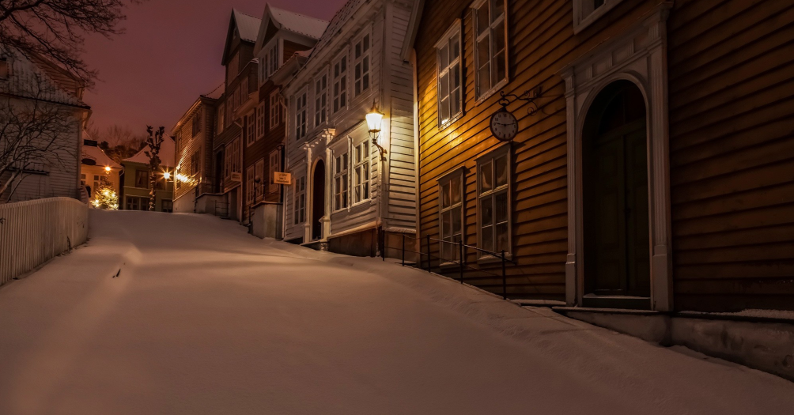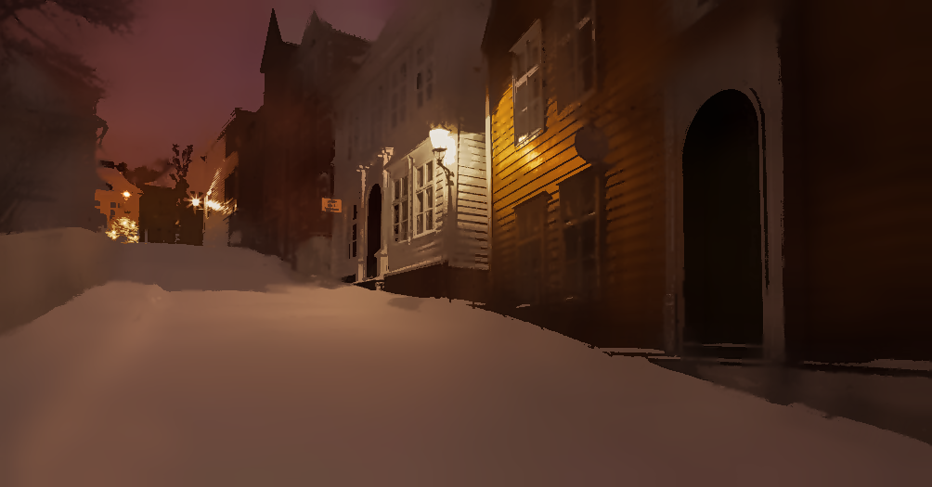

**Original Mean Shifted**

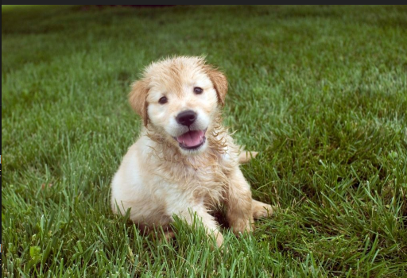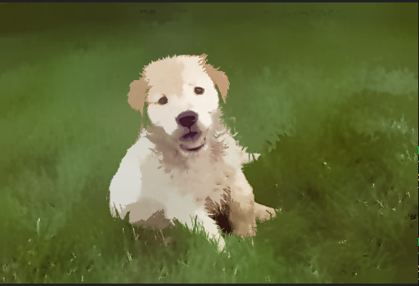

**Original Mean Shifted**

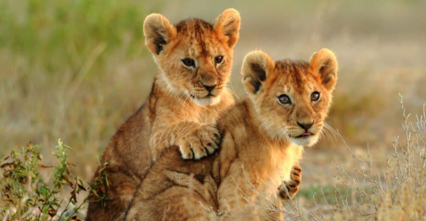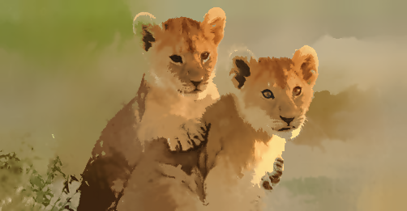

**Original Mean Shifted**

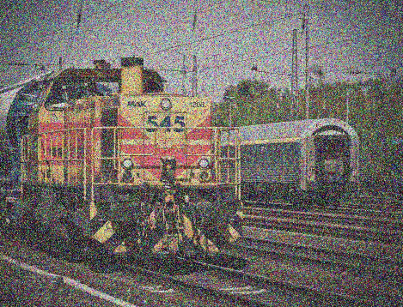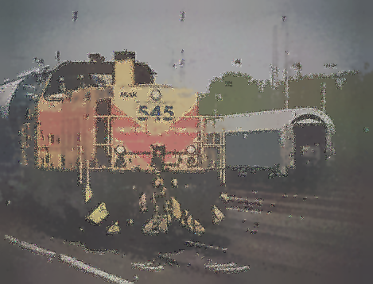

**Due to obvious intensity differences in first two examples (Street and Dog) Mean shift clustering performed well and was able divide (segment) images into clusters successfully.**

**However it terms of images with similar intensities throughout the frame, algorithm was not able to differentiate the clusters that resulted some portion of lion in this case to blend in with background (Ear of the lion in the left and bottom part of lion in the right).**

**Another case where this algorithm has fallen a short is by images with distortion(noise) in it. The rapid change in various locations of the image causes the pixels to be assigned to wrong cluster that leads to unwilling results.**

**Task 2:**

**It is required to apply to Grab-Cut clustering to various images and analyze result by specifying the reasons why in some cases algorithm succeeded or failed. The proceeding with images basic idea behind algorithm should be explained:**

**Unlike clustering that is performed based on intensities, this segmentation Grab-Cut method was initially meant to divide images based on objects that are represented in the scene. The first requirement for algorithm is defined the initial object of interest (by creating bounding box around it). Pixels outside of the boundary are considered as background and pixels inside the boundary are considered as foreground pixels.**

**The Results of the Grab-cut algorithm**

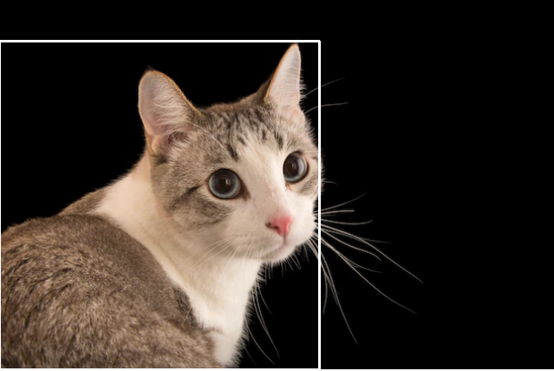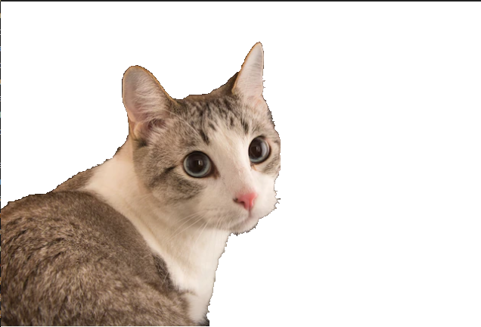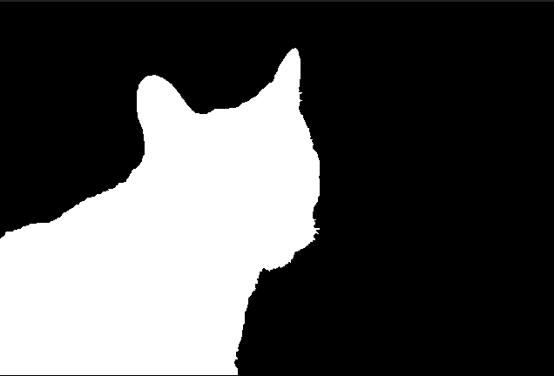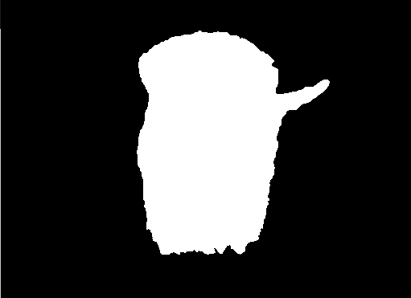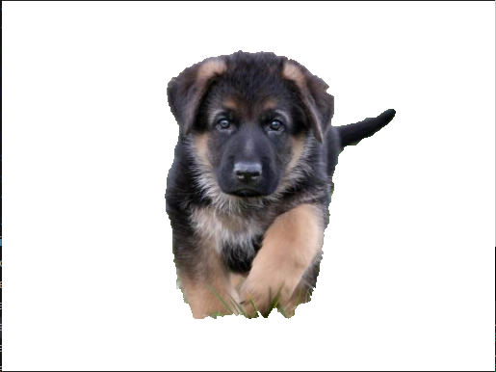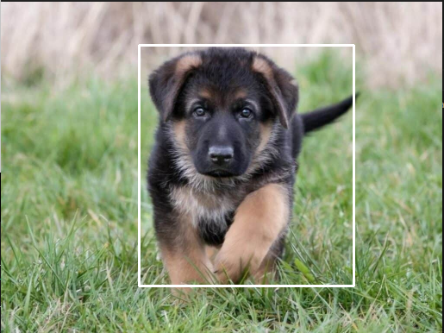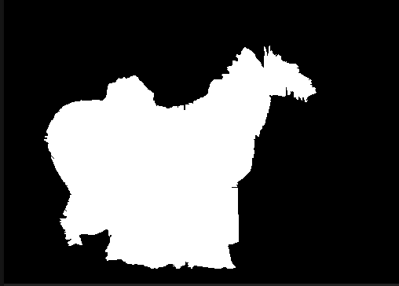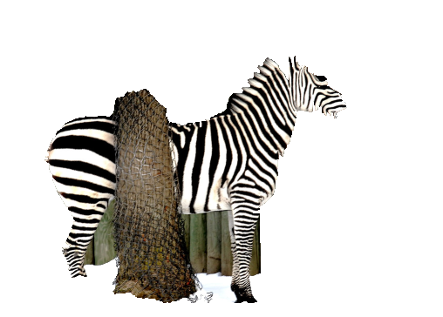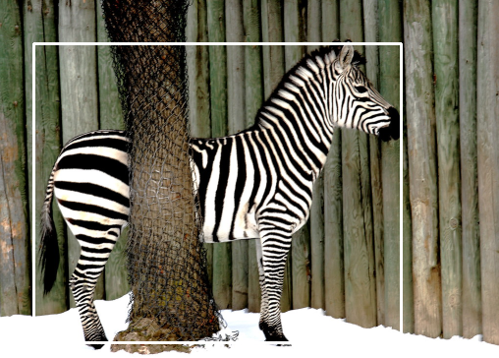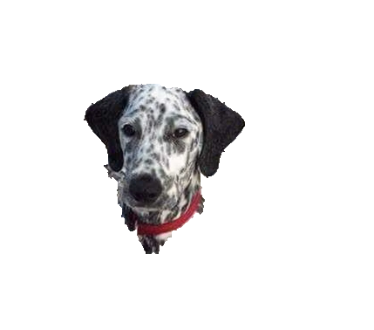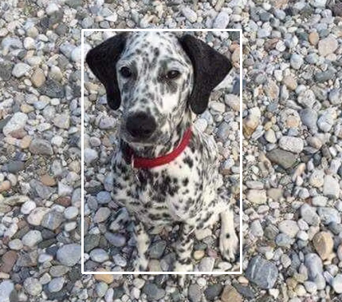

**The first two images are the examples when grab-cut algorithm succeeded because of the rapid intensity difference between foreground and background pixels.**

**The third image failed because of the some portion of the tree was considered as the part of zebra instead of being ignored. When dealing with complex scenes with multiple objects and overlapping regions, Grab-Cut may not handle the interaction between objects well.**

**In the fourth example algorithm failed capturing only some portion of the object instead of whole as intended. This happened because of the similarity in intensities between foreground and background pixels.**

**Notice: Coordinates for bounding box provided in task2.cpp as comments with corresponding image name.**

**Student Name: Javid Guliyev**

**Student ID: 12235421**